**Ahmednagar Jilha Maratha Vidya Prasarak Samaj’s,**

**Shri Dhokeshwar College Takali Dhokeshwar**

**Tal. Parner, Dist. Ahmednagar,**

**State – Maharashtra, Pin – 414304**

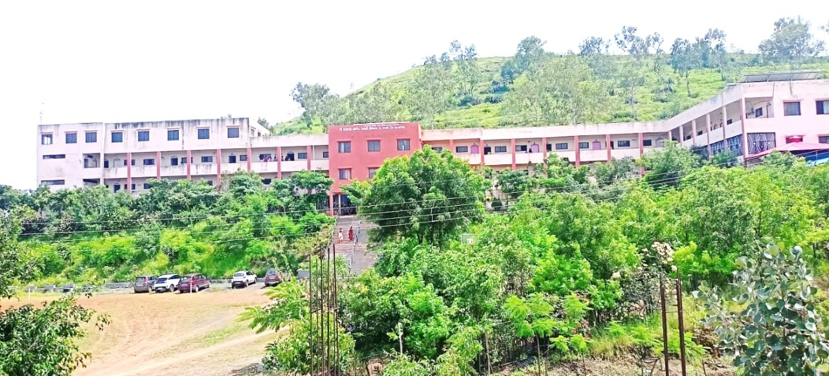

**Rain Water Harvesting**

**(Academic Year :2019-20 to 2021-22 )**

**Ahmednagar Jilha Maratha Vidya Prasarak Samaj’s,Ahmednagar**

**Shri Dhokeshwar College, Takali Dhokeshwar,**

**Tal. Parner, Dist. Ahmednagar**

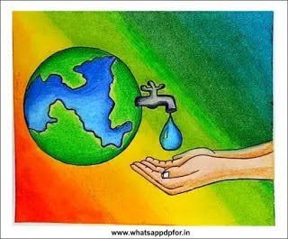 

**Rain Water Harvesting Project**

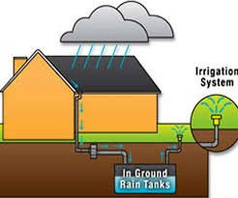

**Academic Year :2018-19 to 2020-21**

**Prepared by Department of Geography**

**INDEX**

|  |  |  |
| --- | --- | --- |
| **Sr. No.** | **Contents** | **Page No.** |
| I | About College | 5 |
| II | Introduction | 7 |
| III | Implementation of Rain Water Harvesting in College Campus | 14 |
| IV | Rain Water Harvesting potential in College campus in last 3 years | 29 |
| V | Conclusion | 33 |
| VI | Map of Rain Water Harvesting in College Campus | 35 |

**About Sanstha**

**Ahmednagar Jilha Maratha Vidya Prasarak Samaj is one of the oldest & pioneering society / trust which has been promoting education since 1918. The Late Chhatrapati Shahu Maharaj of Kolhapur not only inspired but also financially supported the starting of the society** [**achat levitra**](http://pharmacieinde.fr/produit/levitra)**. The progress started with the establishment Late Hutatma Karveer Chhatrapati Shivaji Maharaj Maratha Boarding in 1918. The Residential High School (earlier named as Tagore High School) was established in 1941. From this period onwards development started at a faster pace.**

**The main focus of the society / trust has been to provide education to the economically backward community and for the famine stricken and hilly regions. It has established a network of 89 educational units. This includes 12 Higher & Technical colleges, 25 Higher Secondary Schools, 48 Secondary Schools and 4 Primary & Ashram Schools throughout the Ahmednagar district that impart education in various fields like Arts, Commerce, Science, Education, Law, Engineering, Management, Computer Science & Hotel Management.**

**I. About College**

**Shri Dhokeshwar College was established in 1994 on unaided basis with single faculty of Arts. The very modest objective of founders behind establishing this college in Draught-Prone Area like Takali Dhokeshwar village & its vicinity was to promote education among the deprived classes & especially the girl students, lacking opportunity at a convenient place.** **It received permanent affiliation in 2004 from University of Pune now called as Savitribai Phule Pune University. After completing seven years of its existence & by giving out excellent results in the University Examination, Govt. of Maharashtra was pleased to extend 100% grant since Academic Year 2000-2001. College went through NAAC accreditation process in 2003. As result of it at its successive stages new faculties, courses were initiated like Science Faculty in 2008, Travel & Tourism in 2010, and Commerce Faculty in 2013.**

Shri Dhokeshwar College Takali Dhokeshwar Tal-Parner , is one of the rural area college. Geographically, it located on ‘Deccan plateau’ and climatologically, it lies in the ‘rain shadow zone’ of Parner tehsil Maharashtra state. Therefore, tahsil characterized with low rainfall and it is identified as ‘drought prone area’ in Ahmednagar district. Rocks of the cretaceous system exist may perhaps be inferred from the limestone outcrop at several places. Dykes, boulders and sheet rocks are found in various parts of tahsil. Dykes are all vertical, boulders are loose basalt stones of all sizes and sheets are flat. on the terraces, the soils are too inferior and the hill slopes are stony. the soils not very deep. The climate of the Ahmednagar district and college campus is characterized by a hot summer and generally dryness except during the south-west monsoon season. The tahsil of Parner falls in and most of its area is in the drought prone. The average annual rainfall in the tahsil is 50 cm. September is the rainiest month. About 77% of the annual rainfall is received during the south west monsoon season. , whereas during the Retreat monsoon period rainfall received 16 cm.

Shri Dhokeshwar college Takali Dhokeshwar is located at 19° 9' 28'' North , 74° 22' 54'' East in Ahmednagar district of Maharashtra. The college established on 19 September 1994 run by the Ahmednagar Jilha Maratha Vidya Prasarak Samaj’s. Ahmednagar and affiliated to Savitribai Phule Pune University. It’s mission to provide quality education to all by means of sheer hard work, dedication and devotion. In 2016 the college was re- accredited with grade ‘B’ by NAAC, Banglore. College gives the top priority to academic performance, as any center of learning should in matter of discipline, attendance etc. of students. It is guided by the statutes and ordinances of the Savitribai Phule Pune University, Pune from time to time. The college holds view that no education is complete until the student imbibed with the spirit of social commitment. It is therefore encourages students to exercise their social conscience through various initiatives, including the extension activity of the Savitribai Phule Pune University, Pune. Our objects is to emerge as center of higher learning and to transform the social condition to uphold the moral values of the society strive for the equality, social justice and respect for all the religion through intellectual, physical, cultural and emotional growth of the students.

**II. Introduction**

Water is the most important natural resources for living being. It is common substance on earth, covering more than 70% of the planet’s surface. As the largest natural resource, water is life for all the living species. All living things consist mostly of water. 97% of the water on the Earth is [salt water](https://en.wikipedia.org/wiki/Saline_water) and only 3% is [fresh water](https://en.wikipedia.org/wiki/Fresh_water); slightly over two thirds of this is frozen in [glaciers](https://en.wikipedia.org/wiki/Glacier) and [polar](https://en.wikipedia.org/wiki/Polar_climate) [ice caps](https://en.wikipedia.org/wiki/Ice_cap).The remaining unfrozen freshwater is found mainly as groundwater, with only a small fraction present above ground or in the air. Natural sources of [fresh water](https://en.wikipedia.org/wiki/Fresh_water) include [surface water](https://en.wikipedia.org/wiki/Surface_water), under river flow, [groundwater](https://en.wikipedia.org/wiki/Groundwater) and [frozen water](https://en.wikipedia.org/wiki/Frozen_water). Surface water is water in a river, [lake](https://en.wikipedia.org/wiki/Lake) or fresh water [wetland](https://en.wikipedia.org/wiki/Wetland). Surface water is naturally replenished by [precipitation](https://en.wikipedia.org/wiki/Precipitation_(meteorology)) and naturally lost through discharge to the [oceans](https://en.wikipedia.org/wiki/Oceans), [evaporation](https://en.wikipedia.org/wiki/Evaporation), [evapotranspiration](https://en.wikipedia.org/wiki/Evapotranspiration) and [groundwater recharge](https://en.wikipedia.org/wiki/Groundwater_recharge). The only natural input to any surface water system is precipitation within its [watershed](https://en.wikipedia.org/wiki/Drainage_basin). The total quantity of water in that system at any given time is also dependent on many other factors. These factors include storage capacity in lakes, wetlands and artificial [reservoirs](https://en.wikipedia.org/wiki/Reservoir_(water)), the permeability of the [soil](https://en.wikipedia.org/wiki/Soil) beneath these storage bodies, the [runoff](https://en.wikipedia.org/wiki/Surface_runoff) characteristics of the land in the watershed, the timing of the precipitation and local evaporation rates. All of these factors also affect the proportions of water loss.

Humans often increase storage capacity by constructing reservoirs and decrease it by draining wetlands. Humans often increase runoff quantities and velocities by paving areas and channelizing the stream flow. Natural surface water can be augmented by importing surface water from another watershed through a [canal](https://en.wikipedia.org/wiki/Canal) or [pipeline](https://en.wikipedia.org/wiki/Pipeline_transport)

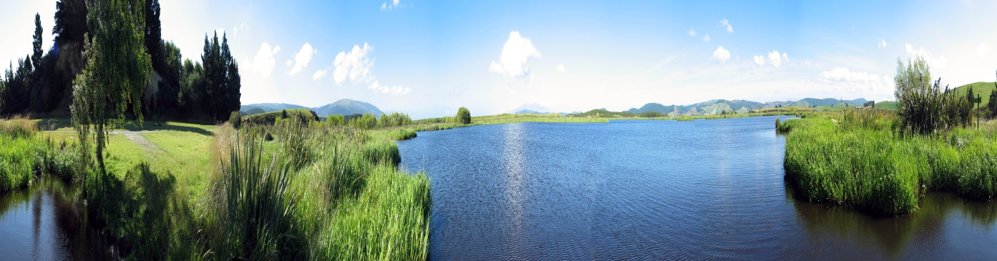

For improving per capita water availability in the country, replenishment of ground water resources is a necessity which can be done very effectively through rain water harvesting. The harvested rain water can also be used directly for various purposes, which will improve per capita water availability substantially.

* **What is Rainwater Harvesting?**

The Rain water harvesting is the process of collection and storage of rainwater from surfaces on which rain falls, filtering it and storing it for multiple uses. Rainwater harvesting puts the supply of water back to normal levels. It is the collection and storage of water from surfaces that rain has fallen upon. Rainwater is collected from roof like surface and redirected to a tank, cistern, deep pit(well, shaft or borehole) or reservoir with percolation, so that it seeps down and restores the groundwater. Rainwater harvesting systems are designed after assessing site conditions that include rainfall pattern, incident rainfall, subsurface strata and their storage characteristics. Rainwater harvesting is popular all across the world, although in countries that are very dry, such as Australia, it is even more popular.

The ‘Rain Water Harvesting’ is attempting to study survey of the water management of rain water of college campus. It tries to see out whether college follows University rules. It also tries to see, whether college is using rain water properly in the college campus. This water can be utilized in the science laboratory and also useful in botanical garden. The ground level of water in college campus has been increased due to rain water preservation. This consoled water can be utilized for varies purposes.

* **Methods of Rain Water Harvesting :**

There are three methods of harvesting rain water as given below:

* Storing rain water for direct use.
* Recharging ground water aquifers, from roof top run off
* Recharging ground water aquifers with runoff from ground area 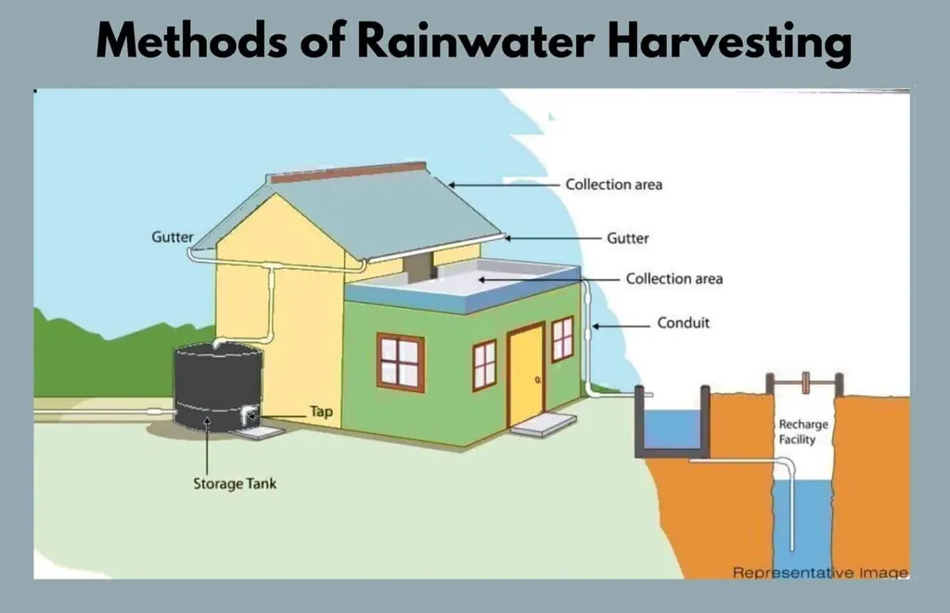
* **Aims and Objectives of Rain Water Harvesting :**
* To bring awareness among students to save water.
* To increase underground water level of the region.
* Bring awareness in society regarding water conservation.
* To Increase underground water level of the college premises
* To create greenery in college campus with storing rain water.
* **Storing rain water for direct use :**

In place where the rains occur throughout the year, rain water can be stored in tanks. However, at places where rains are for 2 to 3 months, huge volume of storage tanks would have to be provided. In such places, it will be more appropriate to use rain water to recharge ground water aquifers rather than to go for storage. If the strata are impermeable, then storing rain water in storage tanks for direct use is a better method. Similarly, if the ground water is saline/unfit for human consumption or ground water table is very deep, this method of rain water harvesting is preferable.

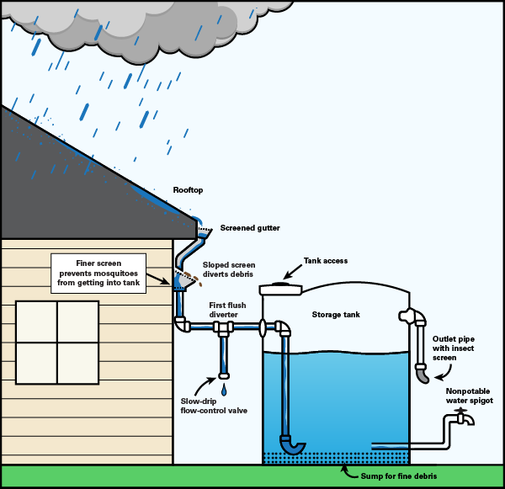

* **Recharging ground water aquifers from roof top run off :**

Rain water that is collected on the roof top of the building may be diverted by drain pipes to a filtration tank (for bore well) from which it flows into the recharge tube well. The recharge tube well should preferably be shallower than the water table. This method of rain water harvesting is preferable in the areas where the rainfall occurs only for a short period in a year and Water table is at a shallow depth.

* **Recharging ground water aquifers with runoff from ground areas:**

The rain water that is collected from the open areas may be diverted by drain pipes to a recharge bore well through filter tanks. The abandoned bore well can be used cost effectively for this purpose.

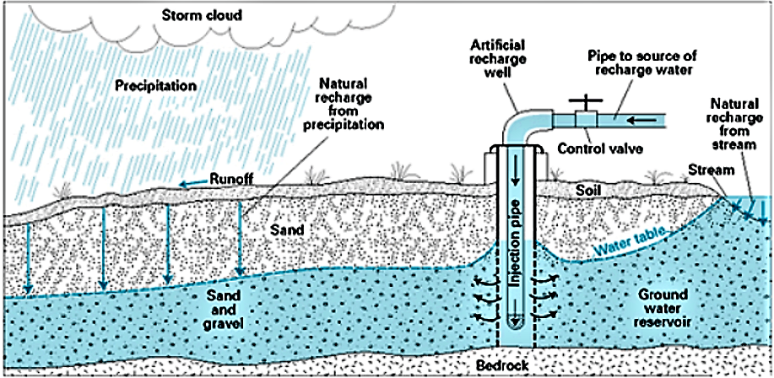

* **Environmental Advantage :**

Collecting the rain that falls on a building and using the same for various purposes is a simple concept. Since the rain you harvest is independent of any centralized system, you are promoting self-sufficiency and helping to foster an appreciation for this essential and precious resource. The collection of rain water not only leads to conservation of water but also energy since the energy input required to operate a centralized water system designed to treat and pump water over a vast service area is bypassed. Rain water harvesting also lessens local erosion and flooding caused by runoff from impervious cover such as pavement and roofs, as some rain is instead captured and stored.

Thus, the storm water run-off, the normal consequence of rain fall, which picks up contaminants and degrades our water ways, becomes captured rainfall which can then fulfill a number of productive use. Policymakers would have to reconsider present assumptions regarding impervious cover and consequent run-off management strategies when rain water harvesting systems are installed.

* **Qualitative Advantage :**

A compelling advantage of rain water over other water sources is that it is one of the purest sources of water available. Indeed, the quality of rain water is an overriding incentive for people to choose rain water as their primary water source, or for specific uses such as watering houseplants and gardens. Rain water quality can be influenced by characteristics of area where it falls, since localized industrial emissions affect its purity. Rain water’s purity also makes it an attractive water source for certain industries for which pure water is a requirement.

For our water requirement we entirely depend upon rivers, lakes and ground water. However rain is the ultimate source that feeds all these sources. Rain water harvesting means to make optimum use of rain water at the place where it falls i.e. conserve it and not allow draining away and causing floods elsewhere. The rain water harvesting may be defined as the technique of collection and storage of rain water at surface or in sub-surface aquifer before it is lost as surface run off. The augmented resources can be harvested whenever needed.

* **Advantages of Rain Water Harvesting :**
* Promotes adequacy of underground water.
* Mitigates the effect of drought.
* Reduces soil erosion as surface run-off is reduced.
* Decreases load on storm water disposal system.
* Reduces flood hazards.
* Improves ground water quality / decreases salinity by dilution.
* Prevents ingress of sea water in subsurface aquifers in coastal areas.
* Improves ground water table, thus saving energy to lift water.
* The cost of recharging subsurface aquifer is lower than surface reservoirs.
* The subsurface aquifer also serves as storage and distribution system.
* No land is wasted for storage purpose and no population displacement is involved.
* Storing water underground is environment friendly.
* **Need of Rain Water Harvesting :**

Water is one of the most essential requirements for existence of living beings. Surface water and ground water are two major sources of water. Due to over population and higher usage levels of water in urban areas, water supply agencies are unable to cope up demand from surface sources like dams, reservoirs, rivers etc.

This has led to digging of individual tube wells by house owners. Even water supply agencies have resorted to ground water sources by digging tube-wells in order to augment the water supply. Replenishment of ground water is drastically reduced due to paving of open areas. Indiscriminate exploitation of ground water results in lowering of water table rendering many bore-wells dry. To overcome this situation bore wells are drilled to greater depths. This further lowers the water table and in some areas this leads to higher concentration of hazardous chemicals such as fluorides, nitrates and arsenic. In coastal areas like Chennai, over exploitation of ground water resulted in seawater intrusion thereby rendering ground water body's saline. In rural areas also, government policies on subsidized power supply for agricultural pumps and piped water supply through bore wells are resulting into decline in ground water table. The solution to all these problems is to replenish ground water bodies with rain water by manmade means.

**III. Implementation of Rain Water Harvesting in College Campus**

Shri Dhokeshwar Mahavidyalaya, is a college in Takali Dhokeshwar village of Parner tehsil of Ahmednagar district in state of Maharashtra India. Takali Dhokeshwar has a tropical climate and receives low rainfall during Southwest monsoon (June-September) and retreating Northeast monsoon (September-Desember). Average annual rainfall is 657mm. In Maharashtra, Ahmednagar district is known mainly as a drought prone area. Ahmednagar district has an uneven rainfall and the distribution of rainfall is uneven. Therefore, there is need to conserved and stored rain water in Parner tahsil. So college attempt to made implementation of rain water harvesting in college campus.

**COMPONENTS OF RAINWATER HARVESTING SYSTEM**

A rainwater harvesting system comprises of components for - transporting rainwater through pipes or drains, filtration, and tanks for storage of harvested water. The common components of a rainwater harvesting system are

**1. Catchments:** The surface which directly receives the rainfall and provides water to the system is called catchment area. It can be a paved area like a terrace. A roof made of reinforced cement concrete (RCC) have used for water harvesting. Therefore the catchment is the area, which actually contributes rainwater to the harvesting system. The rooftop surface area is nothing but the catchment area which receives rainfall. Catchment areas of the different buildings are measured. This measurement was done manually with the help of reinforced fiber tape which is the simplest technique known as tape survey. Before using the tape, tape was checked for any zero error and also length of the tape was also carefully checked for its accuracy. Given below the table for calculated the rooftop areas of the buildings suited inside the campus. Total Catchment area of college terrace is 713 m2 which is used for water harvesting system.

Rainwater harvesting college catchment area:-

|  |  |  |  |
| --- | --- | --- | --- |
| College building | | 47mt    10mt34.3mt  37mt | |
|  | |  | | --- | |  | | | 24.3mt |
|  |

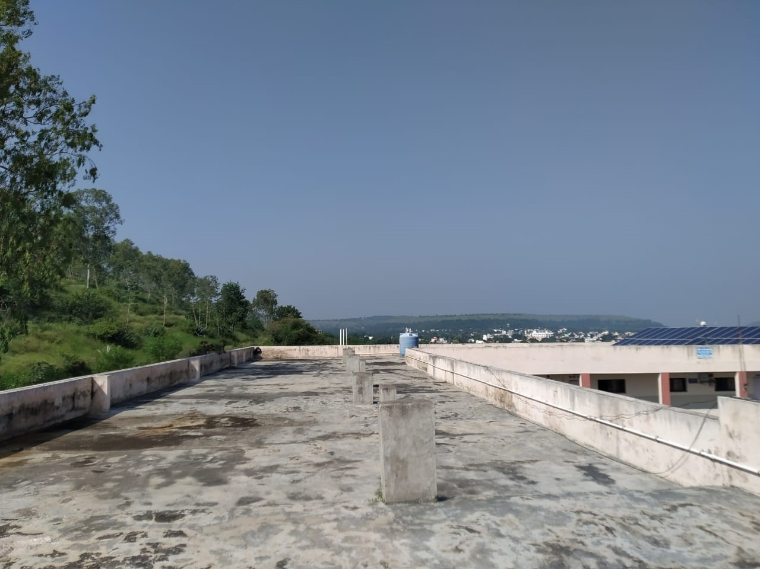

Catchment area of college Building terrace

**2.CONVEYANCE (PIPE)**  
Rainwater from rooftop should be carried through down take water pipes or drains to storage/harvesting system. Water pipes should be UV resistant (ISI HDPE/PVC pipes) of required capacity. Water from sloping roofs could be caught through gutters and down take pipe. At terraces, mouth of the each drain should have wire mesh to restrict floating material

**3. Coarse Mesh:** It prevents the passage of debris, provided in the roof.

4. **Gutters**: Channels which surrounds edge of a sloping roof to collect and transport rainwater to the storage tank. Gutters can be semi - circular or rectangular and mostly made locally from plain galvanized iron sheet. Gutters need to be supported so they do not sag or fall off when loaded with water. The way in which gutters are fixed mainly depends on the construction of the house, mostly iron or timber brackets are fixed into the walls.

5. **Conduits:** Conduits are pipelines or drains that carry rainwater from the catchment or roof top area to the harvesting system. Commonly available conduits are made up of material like polyvinyl chloride (PVC) or galvanized iron (GI).

6. **First-flushing**: A first flush device is a valve which ensures flushing out of first spell of rain away from the storage tank that carries a relatively larger amount of pollutants from the air and catchment surface. First flush is a device used to flush off the water received in first shower. The first shower of rains needs to be flushed-off to avoid contaminating storable/rechargeable water by the probable contaminants of the atmosphere and the catchment roof. It will also help in cleaning of silt and other material deposited on roof during dry seasons Provisions of first rain separator should be made at outlet of each drainpipe.

A first flush system in water harvesting

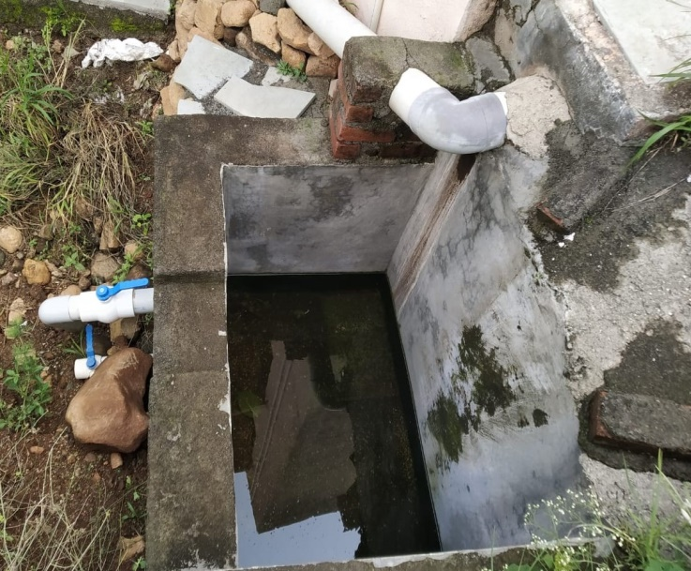 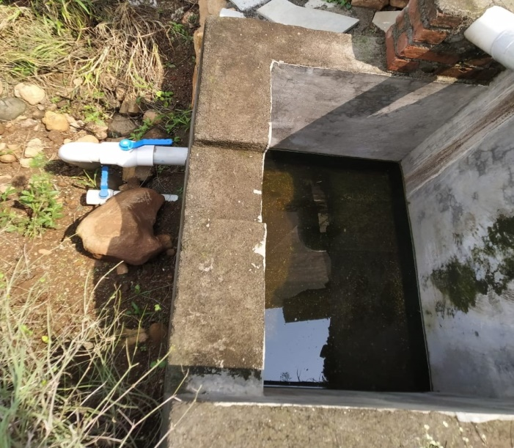

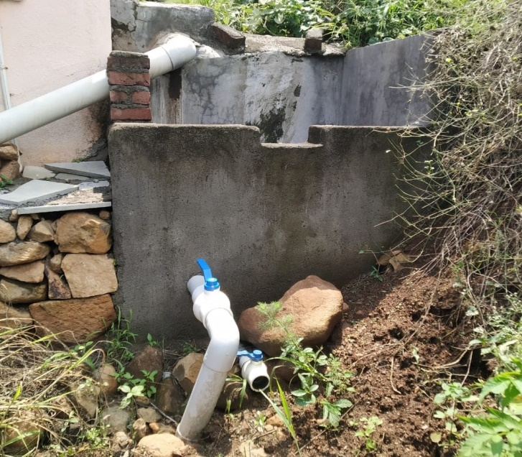 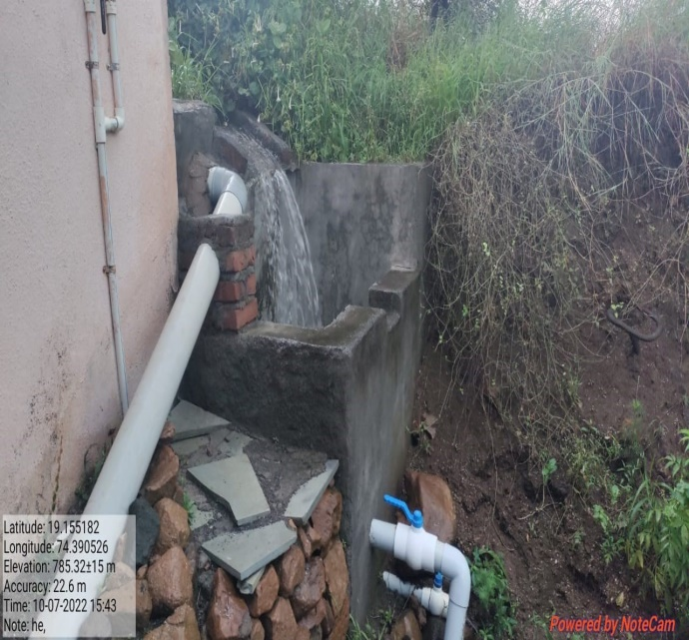

7. **Filters**: The filter is used to remove suspended pollutants from rainwater collected from rooftop water. The Various types of filters generally used for commercial purpose are Charcoal water filter, Sand filters, Horizontal roughing filter and slow sand filter.

8. **Storage facility**: There are various options available for the construction of these tanks with respect to the shape, size, material of construction and the position of tank and they are: -Shape : Cylindrical, square and rectangular. **Material of construction**: Reinforced cement concrete (RCC), masonry, Ferrocement etc. **Position of tank:** Depending on land space availability these tanks could be constructed above ground, partly underground or fully underground. Some maintenance measures like disinfection and cleaning are required to ensure the quality of water stored in the container. If harvested water is decided to recharge the underground aquifer/reservoir, then some of the structures mentioned below are used.

### Storage water tank :- Rainwater storage tanks are used to collect and store filtered rainwater. These tanks can be constructed above ground on a platform. Tanks are painted white to keep the water inside cool, preventing bacteria growth. Tanks are white-washed annually. The top of the tank must remain permanently covered and sealed to prevent the growth of algae or bacteria**.** . An additional tap can be installed in the base of a tank to make emptying for cleaning easier. **Large amount of rainwater store to water tank which is constructed at college campus.** Cylindrical **shape of water tank and material of construction is** Reinforced cement concrete (RCC). These cylindrical shape of water tank radius is 3mt and height 3.6mt.

### The volume of a cylindrical shape of water tank-

### Diameter of the tank- 6 meter

### Thus, the radius of tank =6/2=3 meter

### Height of the tank=3.6 meter

### **Volume of cylindrical water tank= πr2h cubic unit**

### **V= 3.14 x 32 x 3.6**

### **= 3.14 x 9 x 3.6**

### **= 101.736 m3**

### **So total volume of water tank is 101.736 m3**

### **Total storage capacity of water tank =**

### **= Total volume of water tank x 1000 ( 1m3=1000 lit)**

### **= 101.736 m3 x 1000**

### **= 101736 lit**

### 

### **Top of storage water tank**

### ****Total expenditure for the construction of water tank:-****

### **Material of construction is** Reinforced cement concrete (RCC)

Purchased materials for water tank in college as per below details

|  |  |  |  |  |
| --- | --- | --- | --- | --- |
| **Sr.No.** | **Details of material** | **Qantity** | **Rate** | **Total** |
| **1** | **12 mm steel** | **129kg** | **40.50** | **5224** |
| **2** | **8mm steel** | **1056kg** | **41.50** | **43824** |
| **3** | **Cement 53 grade** | **185** | **330** | **61050** |
| **4** | **Baynding wire** | **60kg** | **60** | **3600** |
|  | **Cover block** | **4** | **400** | **1600** |
| **5** | **4” x 6” brick** | **2000** | **5900/1000** | **11800** |
| **6** | **Crush sand** | **20brass** | **3100** | **62000** |
| **7** | **Pawana** | **8 brass** | **1875** | **15000** |
| **8** | **Sand** | **4 brass** |  | **15000** |
| **9** | **Prema latex SBR** | **25 lit** |  | **5725** |
| **10** | **Doctor fixit** | **10 lit** |  | **1200** |
| **11** | **Other** |  |  | **3750** |
|  | **Total** | | | **201273** |

Total wages for construction of water tank in college:-

|  |  |  |  |  |  |  |
| --- | --- | --- | --- | --- | --- | --- |
| **Sr.No.** | **Item** | **No** | **Quantity** | **Unite** | **Rate** | **Amount** |
| **1** | **Excavation** | **1** | **896.2873** | **Cu.Ft.** | **7** | **6274.011** |
| **2** | **P.C.C.** | **1** | **298.7624** | **Sq.Ft.** | **7** | **2091.337** |
| **3** | **Slab** | **2** | **597.5249** | **Sq.Ft.** | **42** | **25096.04** |
| **4** | **R.C.C.Padadi 9”** | **1** | **735.1344** | **Sq.Ft.** | **106** | **77924.25** |
| **5** | **Plaster** | **2** | **1470.269** | **Sq.Ft.** | **14** | **20583.76** |
| **6** | **Beam 12” x 12”** | **2** | **39** | **R.Ft.** | **103** | **4017** |
| **7** | **Column 12” x 12”** | **1** | **12** | **R.Ft.** | **103** | **1236** |
| **8** | **Column plaster** | **1** | **48** |  | **21** | **1008** |
| **9** | **Footing** | **1** | **24** |  | **44** | **1056** |
|  | **Total** | | | | | **139286.4** |

### **Total expenditure for the construction of water tank-**

### **=** Purchased materials for water tank + Total wages for construction of water tank

### **=201273 + 139286**

### **=340559/-**

### **Total expenditure for the construction of water tank which collected rooftop rainwater through PVC pipe is Rs.340559/-**

Rainwater collected from the roof of the building is diverted to a storage tank. The storage tank has to be designed according to the water requirements, rainfall, and catchment availability.

Each drainpipe should have a mesh filter at the mouth and first flush device followed by a filtration system before connecting to the storage tank. Water tank should have an excess water overflow system. Excess water could be diverted to the recharge system.

Water from storage tanks can be used for secondary purposes such as washing and gardening etc. This is the most cost-effective way of rainwater harvesting.

The main advantage of collecting and using rainwater during the rainy season is not only to save water from conventional sources but also to save energy incurred on transportation and distribution of water at the doorstep. This also conserves groundwater, if it is being extracted to meet the demand when rains are on.

**9. Overflow pipe:-** Overflow pipes must be installed in the top of the tank to allow the safe disposal of excess rainwater and to prevent flooding. Overflow water should be drained away to a pit, plant, or storm water drain. The size of the overflow pipe have 4”size which is used the excess rainwater in the water tank away from water tank to recharge trenches through pipeline. It should be the same as that of the inlet pipe, with mesh at the bottom to prevent rats, squirrels, cockroaches, and other pests from entering. The condition of the mesh should be checked weekly to ensure that any damage is repaired immediately.

The expenditure of these pipeline as below –

= Expenditure of total pipe + total rent of JCB

= 17850 + 4800

= 22650/-

Total expenditure of pipeline is 22650/-

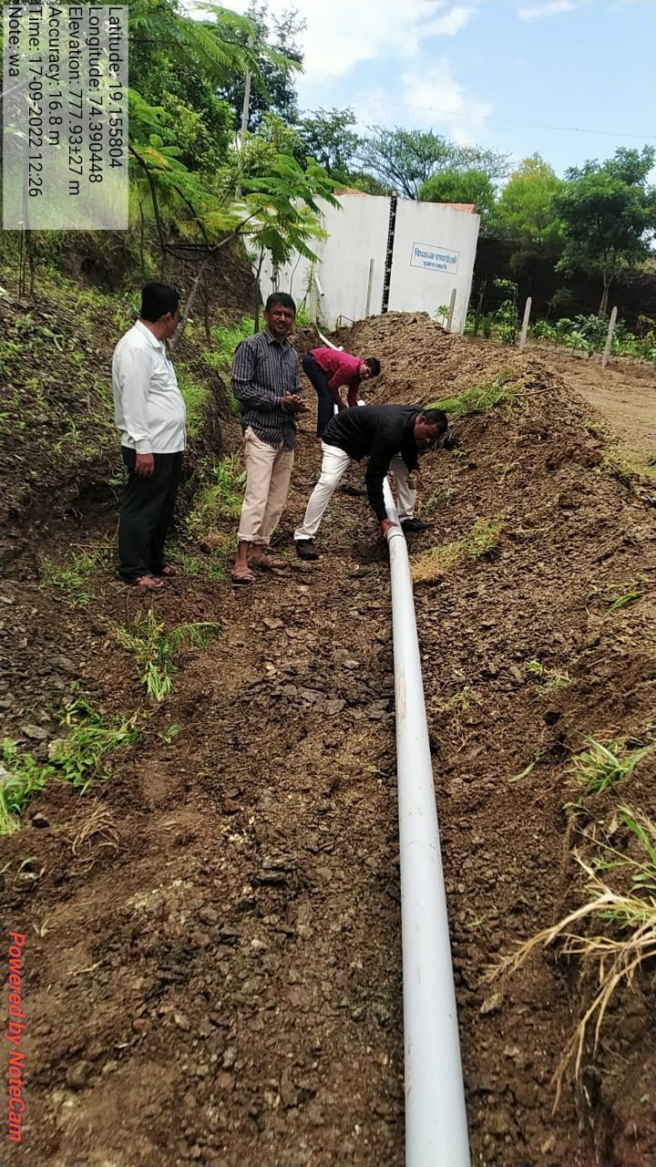

Pipeline for the overflow water from storage water tank to recharge trenches-

10. **Recharge structures**: Excess water may also be used for recharging the aquifer through dug well or abandoned handpump or tubewell etc. Rainwater Harvested can also be used for charging the groundwater aquifers through suitable structures like dugwells, borewells, recharge trenches and recharge pits. Various recharge structures are possible - some which promote the percolation of water through soil strata at shallower depth (e.g., recharge trenches, permeable pavements) whereas others conduct water to greater depths from where it joins the groundwater (e.g. recharge wells). At many locations, existing structures like wells, pits and tanks can be modified as recharge structures, eliminating the need to construct any fresh structures. Some of the few commonly used recharging methods are recharging of dug wells and abandoned tube wells, Settlement tank, Recharging of service tube wells, Recharge pits, Soak ways /Percolation pit , Recharge troughs, Recharge trenches, Modified injection well.

**Recharge Trenches in college campus:-** Recharge trenches are suitable for buildings having roof area of 200-300 m2 and where permeable strata is available at shallow depths.

The mud was removed with the help of a JCB and tractor and an absorption pit/trenches was created on the college grounds. Trenches have 4 m wide, 4.5 m deep and 20 m long depending upon availability of water to be recharged. Groundwater recharge trenches are shallow trenches filled with large size boulders constructed across the land slope in college campus.

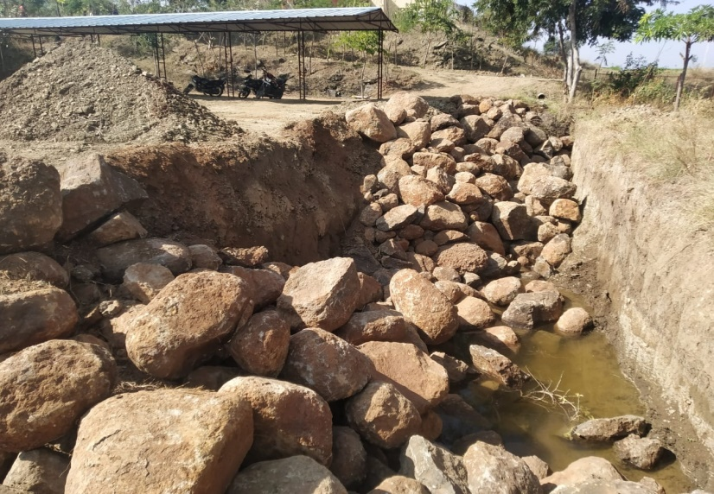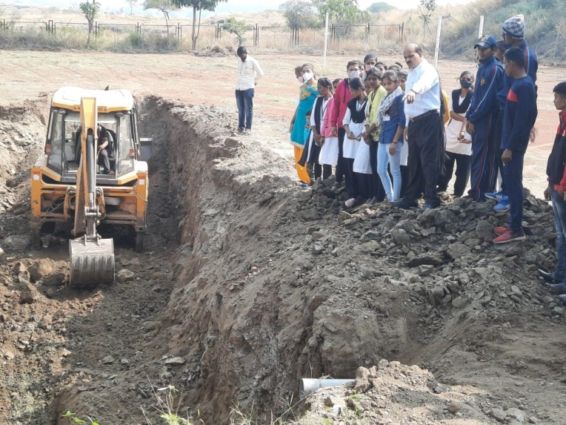

These are backfilled with large size boulders (70-100 cm), in graded form - boulders at the bottom to top. The excess water from constructed water tank through PVC pipe to direct top of the trenches. On the top of the trenches which filled large size boulders covered by HDPE Fabric 300 micron. On these fabric covered by mud and sand material and levelling to the ground surface.

Total volume of the trenches= W x L x H

= 4 x 4.5 x 20

=360 m3

Total expenditure of the recharge trenches-

A) With the help of JCB and Tractor removed the mud and created absorption pit/trenches:- 65000/-

B) With the help of JCB and Tractor filled absorption pit/trenches to large size boulders:-126550/-

C) Total cost of HDPE fabric 300 micron with 29kg :-5800/-

Total expenditure of the recharge trenches = A+B+C

= 65000 +126550 + 5800

= 197350/-

Large size boulder material filled in the recharge trenches

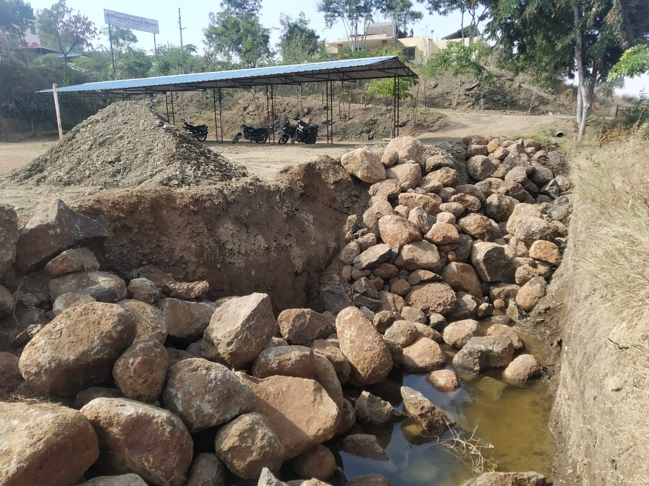

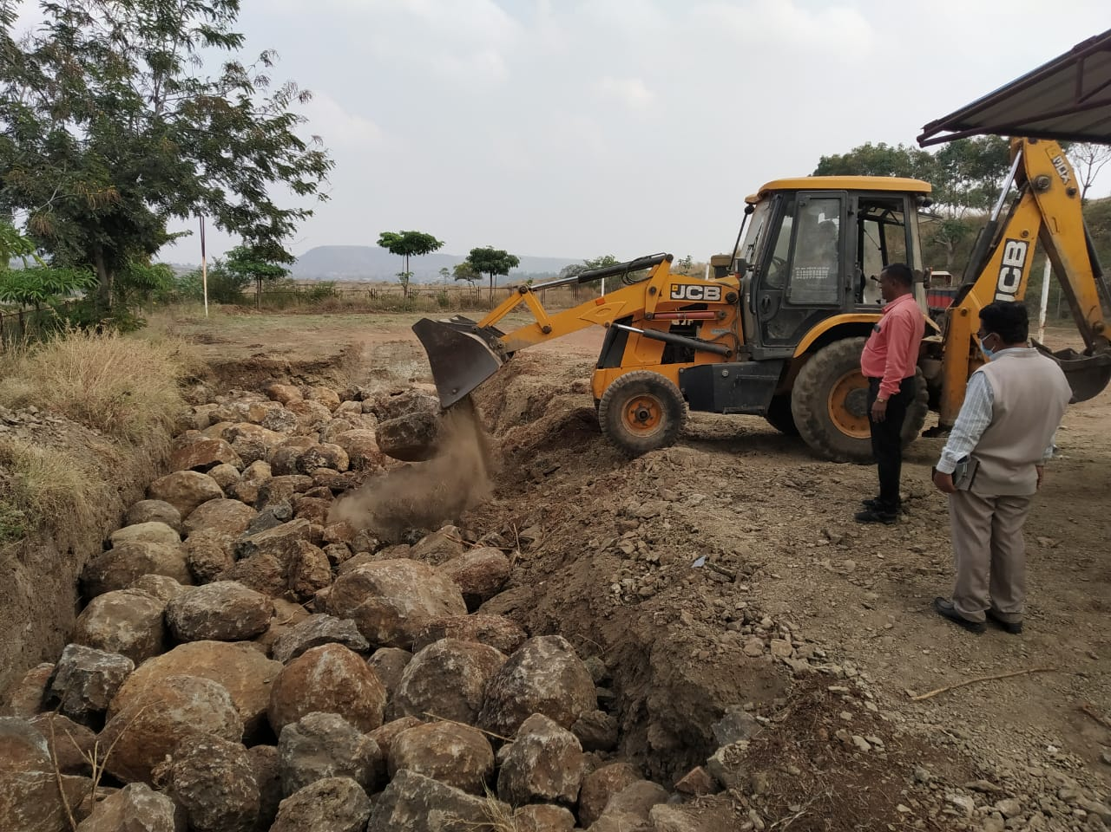

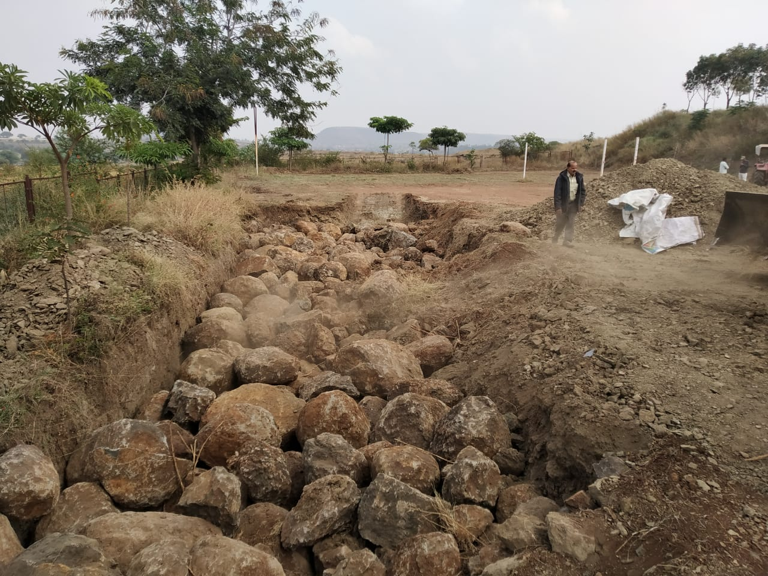

Boulders covered by HDPE Fabric 300 micron

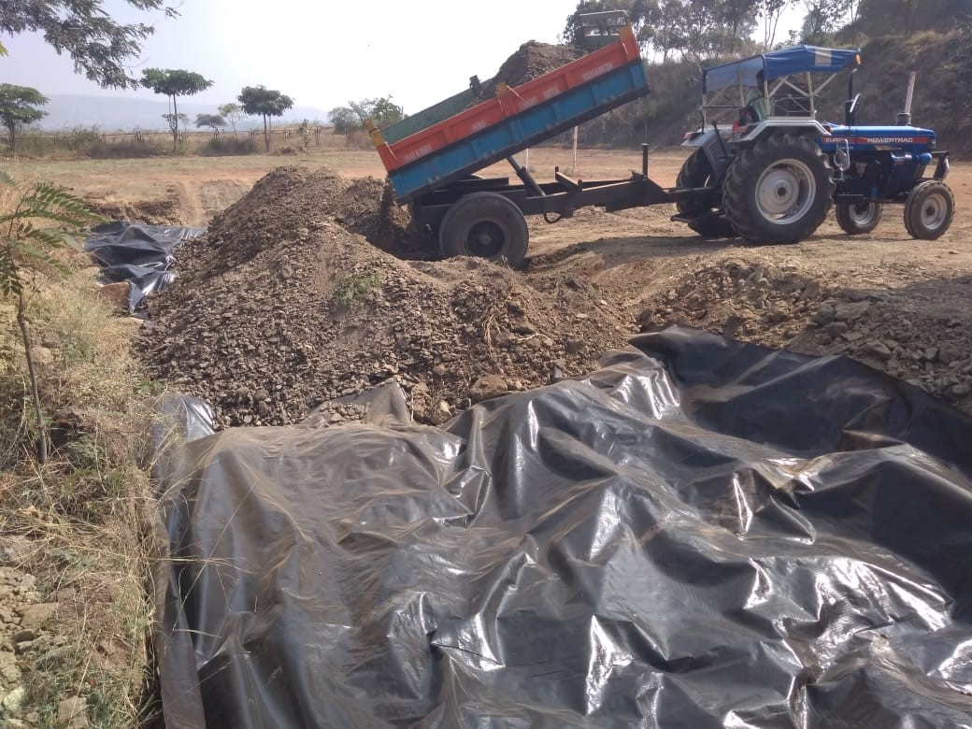

**IV. Rain Water Harvesting Potential**

The total amount of water that is received from rainfall over an area is called the rainwater legacy of that area. And the amount that can be effectively harvested is called the water harvesting potential. The formula for calculation for harvesting potential or volume of water received or runoff produced or harvesting capacity is given as:-

**Harvesting potential or Volume of water Received (m3)**

**= Area of Catchment (m2) X Amount of rainfall (mm) X Runoff coefficient**

All the water which is falling over an area cannot be effectively harvested, due to various losses on account of evaporation, spillage etc. Because of these factors the quantity of rain water which can effectively be harvested is always less than the rain water endowment. The collection efficiency is mainly dependent on factors like runoff coefficient and first flush wastage etc. Runoff is the term applied to the water that flows away from catchments after falling on its surface in the form of rain. For determining rainfall quantity, the rainfall data preferably for a period of at least 10 years is required. This data can be collected from meteorological department.

For determining the pattern of rainfall, the information may be collected either from meteorological department or locally. The pattern of rainfall in a particular catchment area influences the design of rain water harvesting system. In areas where rainfall is more but limited to very short period in a year, big storage tanks would be required to store rain water, if we are collecting rain water in storage tanks for direct use. In such areas, it is preferable to use rain water for recharging of ground water aquifers, if feasible, to reduce the cost of rain water harvesting system. Runoff depends upon the area and type of catchment over which it falls as well as surface features. Runoff can be generated from both pavd and unpaved catchment areas.

Paved surfaces have a greater capacity of retaining water on the surface and runoff from unpaved surface is less in comparison to paved surface. In all calculations for runoff estimation, runoff coefficient is used to account for losses due to spillage, leakage, infiltrations catchment surface wetting and evaporation, which will ultimately result into reduced runoff. Runoff coefficient for any catchment is the ratio of the volume of water that runoff a surface to the total volume of rainfall on the surface. The runoff coefficient for various surfaces is given in table

**Table 1 : Runoff coefficients for various surfaces:**

|  |  |  |
| --- | --- | --- |
| **Sr. No.** | **Type of catchment** | **Coefficients** |
|  | **Roof Catchments** |  |
| 1 | Tiles | 0.8 - 0.9 |
| 2 | Corrugated metal sheets | 0.7 - 0.9 |
|  | **Ground surface covering** |  |
| 3 | Concrete | 0.6 - 0.8 |
| 4 | Brick pavement | 0.5 - 0.6 |
|  | **Untreated ground catchments** |  |
| 5 | Soil on slopes less than 10% | 1. - 0.3 |
| 6 | Rocky natural catchments | 0.2 - 0.5 |

**Source** :

Pacey, Amold and Cullis, Adrian 1989, Rain water Harvesting. The collection of rainfall and runoff in rural areas, Intermediate Technology Publications, London p 55

**IV. Rain Water Harvesting potential in College campus in last 3 years**

College has implemented roof rain water harvesting of Building. (Refer enclosed figures of rain water harvesting). Rain water is collected in college store water Tanks which capacity 100000 lit, Recharge Bore Well, and used for Greenery during summer and winter season. To reduced runoff, college also planted number of trees it helps to conserved and percolate rain water in college campus.

Based on the above table 1, the water harvesting potential of site could be estimated using the following equation:

**Rain Water harvesting potential =**

**Amount of Rainfall x Area of catchment x Runoff co-efficient**

The calculation for runoff can be illustrated during the year 2019-20 in college campus:-

A building with flat terrace Area (A)-713 m2

The average annual Rainfall (R) in (mm). 654mm (0.654m)

The runoff co-efficient (C). 0.8

**Annual water harvesting potential ( m3) = A x R x C**

**= 713m2 x 0.654m x 0.8**

**= 373.0416 m3**

**= 373.0416 x 1000 (1m3=1000lits)**

**= 373041 lits**

Rain water harvesting potential during the year 2020-21:-

A building with flat terrace Area (A)-713 m2

The average annual Rainfall (R) in (mm)- 870mm (0.870m)

The runoff co-efficient (C)- 0.8

Annual water harvesting potential ( m3) = A x R x C

**= 713m2 x 0.870m x 0.8**

**= 496.248 m3**

**= 496.248 x 1000 (1m3=1000lits)**

**= 496248 lits**

Rain water harvesting potential during the year 2021-22:-

A building with flat terrace Area (A)-713 m2

The average annual Rainfall (R) in (mm)- 720mm (0.720m)

The runoff co-efficient (C)- 0.8

Annual water harvesting potential ( m3) = A x R x C

**= 713m2 x 0.720m x 0.8**

**= 410.688 m3**

**= 410.688 x 1000 (1m3=1000lits)**

**= 410688 lits**

**Total Cost of the Rain Water Harvesting System –**

### = **Total expenditure for the construction of water tank +** The expenditure of pipeline + Total expenditure of the recharge trenches

### = **340559 +** 22650 + 197350

### = 560559/-

**Total Cost of the Rain Water Harvesting System Rs.560559/-**

This is one time investment for construction of this Unit. The maintenance cost of the unit is very less as there only need maintenance for pipe line and filter units.

**V. Conclusion**

* Rainwater harvesting has helped to replenish ground water of college campus and surrounding areas.
* The total cost of the rain water harvesting system is Rs.560559/- calculated and suggested.
* The college has been using rainwater harvesting from the last three year.
* This water is collected in storage tank. It is also used to recharge ground water through recharge trenches.
* This water helps to water plants and trees in botanical garden, Science lab, college campus.
* Thus rain water harvesting has helped to save run - off water to meet different needs of college. It is also helped to increased ground water level.

**References**

[1] A Water Harvesting Manual for Urban Areas: Case Studies from Delhi. 2003. New Delhi: Centre for Science and Environment.

[2] Centre for Science and Environment. 2003. Site dedicated to Rainwater Harvesting. Accessed on various dates at

[3] http://www.rainwaterharvesting.org/

[4] Government of India. 2003. Ground Water in Delhi: Improving the sustainability through Rainwater Harvesting, Central Ground Water Board, Ministry of Water Resources.

[5] Government of India. 2003. Rainwater Harvesting: A necessity in South and Southwest Districts of NCT, Delhi. State Unit Office, Delhi, Central ground Water Board, Ministry of Water Resources. Government of India. 2003. Details on Water Harvesting. Accessed on various dates at http://www.cgwaindia.com/

[6] Key Issues. September 2000. Water harvesting: urgent need to reap rich rewards [Article] Indian Energy Sector, TERI 2000. Accessed on 15 May 2003 at http://www.teriin.org/energy/waterhar.htm

[7] Kumar, M. Dinesh. 2003. Paper: Roof Water Harvesting for Domestic Water Security: Who gains and who loses? Under review.

[8] A Water Harvesting Manual, Centre for Science and Environment http://www.cgwaindia.com/suo/home.htm

[9] http://www.rainwaterharvesting.org/urban/Components.htm

[10] A Water Harvesting Manual, Centre for Science and Environment

[11] IS 1172: Indian Standard Code of Basic Requirements for Water Supply, Drainage and Sanitation

**Rain Water Harvesting Map in College Campus**

|  |  |  |  |
| --- | --- | --- | --- |
|  | | 47mt    10mt **1** 34.3mt  37mt | |
|  | |  | | --- | |  |     **2** | | 24.3mt    **3** |
|  |

4

1. Rooftop harvesting catchment area 5
2. Garden
3. SD Canteen
4. Rainwater collection chamber
5. 6’ Underground pipeline
6. Storage Water Tank (1 lakh lits)
7. Girls Hostel
8. Bore well
9. Coarse pit/Recharge trenches D
10. 4’ Overflow pipeline **A**

**O 10**

**R**

**7**

9

**8**

**Outlet**